Project 1:Ubuntu instance

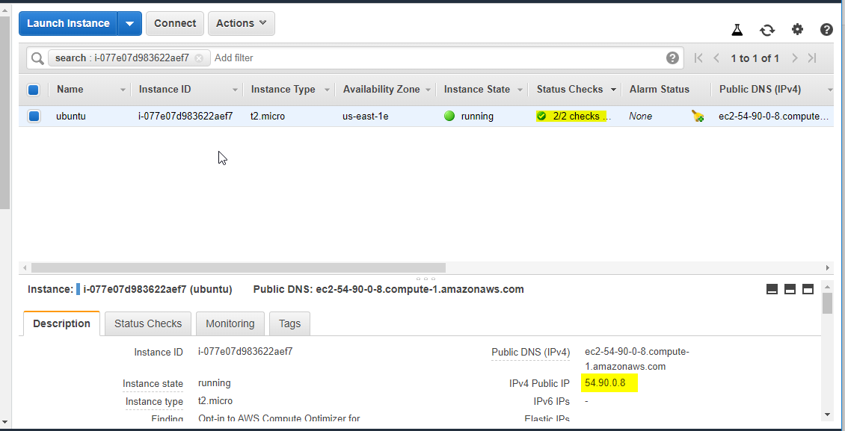

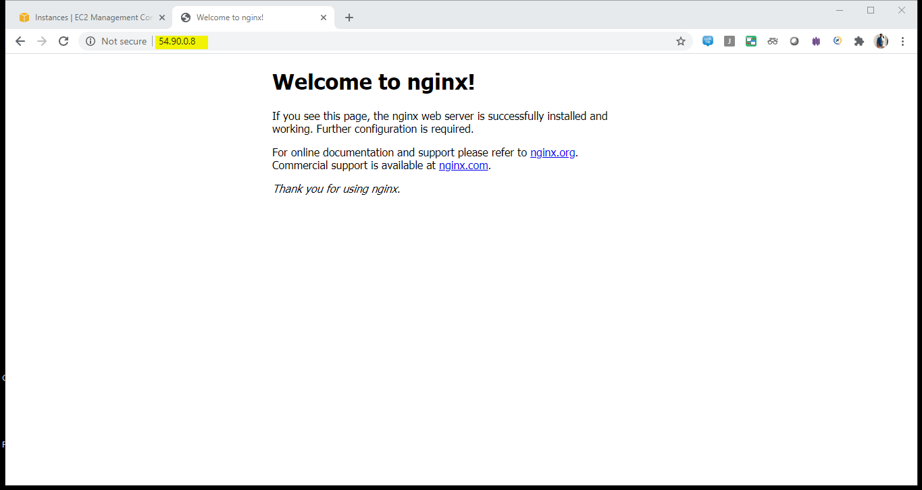

Project 2 windows Instance

As I’m using my company laptop ,there was a setting issue (I already created more window instances)

So it is not creating instance.

